ABSTRACT
As drone technology advances, improving power efficiency in quadcopter-based delivery systems becomes increasingly critical. Greater power efficiency not only extends flight duration and mission reliability, but also opens the door to predictive power performance through machine learning. Choosing power is an effective solution as it is more granular in terms to better handle errors and improves efficiency. This research uses machine learning to present a fine-grained, per-entry prediction model for two key electrical parameters—battery current and power consumption. Here, 188 drone flights data was pretty enough to extract great results and insights into real time energy consumption patterns. Five regression models were implemented and compared: Linear Regression, Random Forest Regressor, Gradient Boosting Regressor, LightGBM, and Multi-Layer Perceptron (MLP). LightGBM significantly outperformed the others, achieving an R² score of 0.9867 after hyperparameter tuning. Evaluation using standard performance metrics and actual-vs-predicted plots confirms the model's precision and robustness. The study highlights the potential of machine learning to enable more energy-efficient, reliable, and intelligent Unmanned Aerial Vehicles (UAV) delivery missions through proactive battery and mission management.

1. INTRODUCTION
The quick development of Unmanned Aerial Vehicles (UAVs), especially quadcopters, has made promising last-mile small-package delivery opportunities possible, providing quick on-demand logistics with low infrastructure needs. With more e-commerce firms aggressively seeking same-day delivery models, the demand for flexible and effective delivery systems has significantly increased. Quadcopters with Vertical Takeoff and Landing (VTOL) characteristics are ideal for operating in both heavy urban areas and distant areas [1]–[3]. Yet, their large-scale use is inherently limited by power consumption and finite battery life, which limits payload capacity, flight range, and overall operational feasibility [4]–[8]. Knowledge of power consumption and current draw through phases of flight—such as takeoff, climb, cruise, turbo acceleration, hovering, and landing—is key to optimal UAV performance. Empirical research, such as from Rodrigues et al.[9], integrates first-principles modeling with machine learning through extensive flight testing and documents energy consumption rates of approximately 0.05 MJ/km, equivalent to about 41 g CO₂ equivalent per package [10]. Other research points to the possibility of values up to 0.08 MJ/km, especially using representative U.S. electricity grid mixes, and underscores the value of precise, real-world energy profiling via onboard telemetry [11].
Energy profiling indicates that takeoff and landing segments expend a disproportionately large portion of total mission energy—usually 30–35%—in resisting gravity [12], [13]. Conversely, cruise segments, though of lower power demand, necessitate sustained energy determined by payload weight, airspeed, and aerodynamic drag. Optimization analyses indicate that reducing energy per kilometer entails finding optimal cruise speeds that optimize these factors [14][16]. Precision determination of the current consumption is normally attained by the incorporations of inline current sensors or telemetry modules into the power distribution system of the UAV. For example, Rodrigues et al.[9] fitted DJI Matrice 100 quadcopters with current and voltage sensors over 209 missions, accumulating more than 10 hours of power use data over a period of around 65 km [10]. Similarly, Stolaroff et al. analyzed drone energy use across different delivery scenarios, emphasizing environmental benefits when powered by low-carbon grids. Dorling et al. developed energy consumption models for UAV routing that account for battery constraints, vehicle mass, and mission profiles. Kim and Choi explored real-time power estimation for multicopters using flight log data and regression techniques, showing how telemetry-based modeling improves prediction accuracy. Their power modeling strategy combines motor electrical parameters—voltage, current, torque constant, and angular speed—along with aerodynamic coefficients to generate phase-resolved estimates of avionics and propulsion power consumption [17]–[20]. These compound models merge physical white box principles with data-driven machine learning strategies [9], [21].
Environmental studies show substantial savings in energy and emissions for quadcopters over conventional ground transport. In clean electricity grid areas, drones produce about 420 g CO₂e per package—about 53% lower than diesel trucks—while in more carbon-intensive electricity areas, such as Missouri, the savings are about 23% [22], [23]. Under ideal conditions, lifecycle analysis reveals potential energy usage reductions of as much as 96% over traditional delivery practices [9], [11]. These, however, are subject to conditions like small payload weights (0.5–2 kg), optimized route management, and takeoff and landing infrastructure energy costs [24]–[26]. On scale, UAV fleet management adds additional layers of complexity. Research indicates that heterogeneous fleets involving small quadcopters in conjunction with bigger multicopters are able to decrease energy consumption by up to 50% over homogeneous fleets [16], [27]. Optimization algorithms that incorporate models of energy along with constraints such as battery exchange, payload capacity, time windows, and routing are dependent largely on phase-resolved current and energy models [28]–[30].
Recent developments in robotics and drone systems increasingly leverage machine learning to enhance autonomy, efficiency, and adaptability. Studies have explored areas such as predictive maintenance, fault detection, and control optimization using learning-based techniques. However, most of this research focuses on operational dynamics or localization, with limited attention given to high-resolution, phase-specific power consumption. This reveals a critical gap where machine learning could significantly contribute to developing smarter, energy-aware UAV operations—particularly for delivery missions constrained by battery limitations.
To mitigate energy-density limitations, solutions like battery-swapping technologies, micro-optical electromechanical systems (MOEMS), fuel cells, solar tethering, and supercapacitor integration have been suggested [31]–[33]. Critiques of endurance-enhancing methods point out the compromises entailed and pave the way for future UAV operations beyond the short-range delivery [34]. Notwithstanding these innovations, there still are research gaps in the existing literature. Most models have no high-resolution telemetry, are unable to measure phase-specific current draw in diverse payload conditions, or omit avionics energy usage. Other regulatory issues—no-fly zones, altitude limits, weather variation, and obstacles—add complexity to flight planning and energy modelling [12], [35]. The aim of this work is to overcome these weaknesses by creating and implementing a high-resolution onboard current and voltage data acquisition system. Controlled flight testing is performed over a variety of payloads (0–2 kg), cruise velocities (5–15 m/s), and wind conditions. The data obtained are divided by phase of flight to determine the effect of payload and speed on average and peak current consumption, and energy use per phase and over entire missions. The research compared with the other existing literature of UAV energy, and assesses battery safety margins, flight range, and carbon emissions using various grid electricity mixes. Finally, the findings provide insight into important UAV system design elements, such as battery sizing, controller thermal management, and data-driven mission planning strategies.

2. RELATED THEORY
Here, we outline the theoretical underpinnings of the machine learning models utilized in power consumption and current drawn prediction during quadcopter drone flight. The models were chosen because of their ability to represent nonlinear relations, reduce prediction error, and scale with real time flight telemetry data.

2.1. Linear Regression
Linear Regression is an easy statistical technique that illustrates the variation between one or more independent variables and a dependent variable by finding a best-fitting linear equation to the observed data. It accounts for the reality that there is linear correlation between the predictors and the output. The mathematical formula is:
𝑦 =𝛽0 + 𝛽1𝑥1 + 𝛽2𝑥2 + ⋯ + 𝛽𝑛𝑥𝑛 + 𝜖
where y is the target (e.g., power consumption), 𝑥1, 𝑥2, …, 𝑥𝑛 are input features (e.g., payload, flight speed, altitude), and ϵ represents the error term.
Linear regression is a go-to model for quadcopter power estimation. It’s very simple to comprehend and is computationally inexpensive, making it ideal for quick testing or edge deployment. But that’s also its downfall. Physical quadcopter flight dynamics include complex interactions between variables such as wind resistance, throttle control, and battery efficiency, and these interactions are likely to be nonlinear in nature. So, while linear regression does project coarse trends, it tends to come up short in terms of capturing finer patterns needed for good energy prediction. Still, it’s a decent baseline to measure the efficacy of more complex models.

2.2. Random Forest Regressor
Random Forest is an ensemble learning algorithm where numerous decision trees are constructed during training and mean of the tree prediction is provided during regression. In contrast to a single decision tree, which is prone to overfitting, Random Forest operates by using the bootstrap aggregation (bagging) method in such a way that every tree is trained on a random subset of data and a random subset of features. This reduces variance with little bias, and this improves generalization.
With quadcopter operation, flight data is noisy and may include sensor oscillations, variability of the environment (e.g., wind) and payload-induced changes. Random Forest is particularly capable of handling such diverse complexities as it is robust to noise and can handle non-linear relationships. It also provides information on feature importance, so it becomes feasible to identify which of the flight parameters (e.g., altitude, speed, payload mass) most affect power consumption or drawn current.
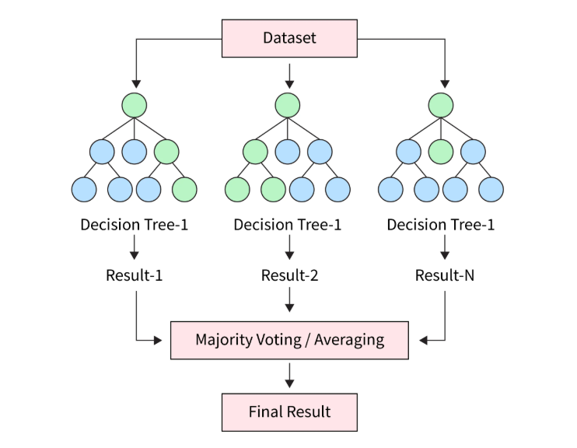
Figure (1). Decision trees working in Random Forest regressor
One likely drawback is that random forest models during prediction time are computationally costly and less than simple models. But they have a satisfactory compromise between accuracy and stability and are thus most appropriate to middle level drone prediction tasks, especially when real time prediction is not a paramount need.

2.3. Gradient Boosting regressor
Gradient boosting regressor gradient boosting as a robust ensemble method that builds prediction models in a stage wise fashion, usually with decision trees as the base learners. Unlike Random Forests where the trees are individually trained, Gradient boosting trains the trees sequentially. Each new tree enhances the residual error of the previous ensemble using a gradient descent algorithm to minimise a specified loss function i.e., mean squared error.
This method is very effective at quantifying subtle, non-linear behaviour typical in drone telemetry data. Minor variations in flight trajectory, motor loading or weather, for instance could have a drastic effect on current raw and power consumption - behaviours that are easily learned by gradient boosting. It will perform more accurate models than bagging- based methods if well-tuned.
However, the algorithm is hyperparameter-sensitive to tree depth, the number of trees, and the learning rate. It is also computationally more expensive to train, which might be a concern when on-device learning is to be done. But due to its ability to produce high-fidelity, high precision predictions, the algorithm is ideally suited to capture the dynamic of energy in drone logistics Where efficiency gains directly translate to delivery feasibility and flight time optimization.
2.4. LightGBM Regressor
LightGBM regressor or Light Gradient Boosting Machine, is a state-of-the-art, high-performance version of gradient boosting developed by Microsoft. It is designed to be efficient in performant, especially on large data, with histogram-based methods and leaf-wise tree growing techniques. Contrary to standard level-wise tree growing, LightGBM does tree growing in a vertical manner, splitting the leaf with the highest loss reduction, which leads to deeper, more precise tree with fewer interactions.

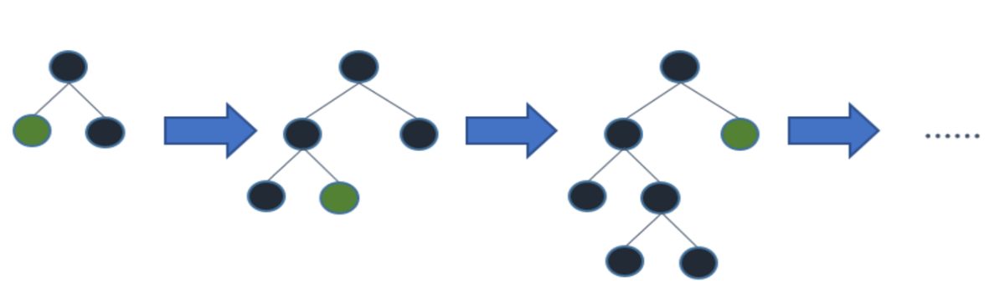
Figure (2). Leaf-wise tree growth working
LightGBM can be applied to quadcopter power reduction since it is designed to operate with high-dimensional telemetry readings such as GPS, IMU, and motor sensors at scale. LightGBM is also robust with missing and categorical values and converges faster than conventional gradient boosting algorithms, which is worth it when processing large-scale drone flight logs or real time streams of telemetry.
Though its power, leaf wise growth, tends to lead to overfitting in noisy small datasets when not regularized, Otherwise, when well-tuned, it provides the best performance and is typically the go-to option in competitive machine learning tasks. In drone energy modelling, its tradeoff between accuracy and speed is perfect for offline training and subsequent real-time use when computational power is not highly limited.

2.5. Multilayer Perceptron (MLP) Regressor
Multilayer Perceptron (MLP) Regressor is a feedforward neural network that accepts sets of input data and transforms them into appropriate values for output through layers composed of interconnected neurons. A neuron calculates a weighted sum of the inputs and then applies a non-linear activation function, and the model is able to learn complex Relationships that are difficult to model with traditional methods. When power production based on drones, MLPs are useful when input features have non-additive interaction – i.e., When the total effect of altitude, Speed, and load on battery performance is different from the effect of each feature taken alone. MLPs Are you capable of dealing with such high-dimensional, Nonlinear interactions effectively. They are also capable of generalizing well if trained on an adequate amount of data and regularization methods such as dropout or L2 norm penalties. Nonetheless, neural Networks are typically handled as black boxes. They’re not inherently interpretable,
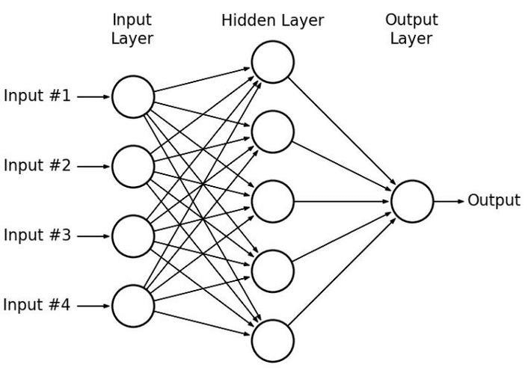
Figure (3). Working of layers in MLP regressor
which can make it difficult to justify predictions for safety-critical uses such as drones. In addition, MLPs Are highly architecture and hyperparameter hungry (number of layers, number of neurons in each layer) And require considerably more Computationally intensive resources than tree models. However, characterising the nuanced dynamics of current consumption under a wide variety of flying conditions, MLPs Provide an incredibly effective modelling technique when interpretability is not so much of a concern.

3. METHODOLOGY
3.1. Research objective and motivation
This study aims to predict the current drawn and power consumption of a quadcopter at the per-log-entry level, rather than over full flights or phases. Such granular prediction enables real-time power monitoring, anomaly detection, and energy-aware flight control. Previous research typically focused on estimating total energy usage over complete missions. In contrast, our approach models energy characteristics per timestamp, capturing detailed variations caused by changes in payload, speed, or altitude. This resolution is particularly useful for small delivery drones, which operate under tight energy constraints. We implement and compare five machine learning regression models to achieve this: Linear Regression, Random Forest, Gradient Boosting, LightGBM, and MLP Regressor, evaluating their accuracy, efficiency, and suitability for embedded applications.
3.2. Dataset Description and Preprocessing
The dataset used contains individual log entries recorded during quadcopter drone M-100 operation. To be very precise, the dataset is recorded from 188 flights of quadcopter drone M-100 In which approximately 2.57 lakhs data entries are stored. Each row has flight and electrical parameters like altitude, payload, speed, current, and voltage. Instantaneous power is calculated as the product of current and voltage. Data cleaning involved removing missing or anomalous values and standardizing numeric features. No aggregation by flight phase was performed; the data remains at full timestamp-level granularity. Categorical variables (if any) were encoded, and features were normalized where required for model training. The dataset was split into 80% for training and 20% for testing.
3.3. Feature Selection and Target Engineering
In this study, explicit feature selection was not done but all numerical columns (excluding the targets i.e. battery current and power consumption) were used as model inputs. This helped model to learn from a wide set of potentially relevant target as a in real time, small change in orientation can affect power consumption and also battery current needed. Features included telemetry battery data, environmental conditions, and derived parameters such as gps_speed and flight_time. The target variables were engineered to gain fine-grained power consumption and current drawn behaviour.
- battery_current (in amperes), directly measured from the drone's sensors
- power_consumption, computed as battery_voltage × battery_current for each log entry

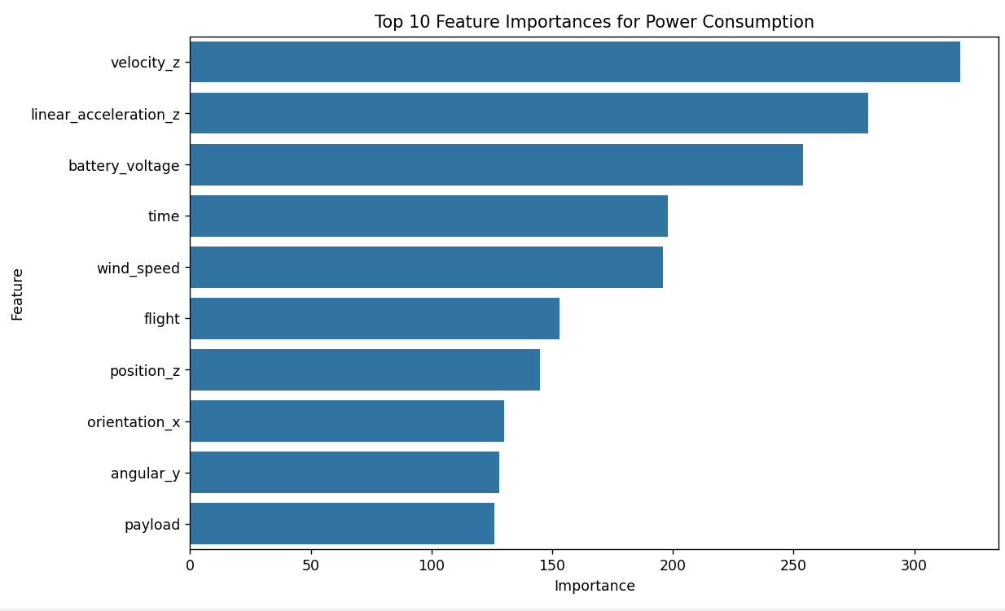
Figure(4.1): Bar plot representing feature importance for power consumption
This granular, per-row prediction approach provides high-resolution insights into drone energy usage. Though feature selection wasn't applied, feature importance scores from tree-based models were later analyzed to identify key drivers of current and power consumption.
3.3.1 Payload-wise Energy Analysis
To explore how different payloads affect the power consumption of the drone, we grouped the data by payload weight and calculated the average power used in each case. The results are shown in Figure (4.2). We can see a clear pattern—when there is no payload (0 g), the average power consumption is around 340 W. As the payload increases to 250 g and 500 g, the power demand rises, reaching a peak of about 440 W at 500 g. However, when the payload increases further to 750 g, the average power originally drops slightly to around 380 W.

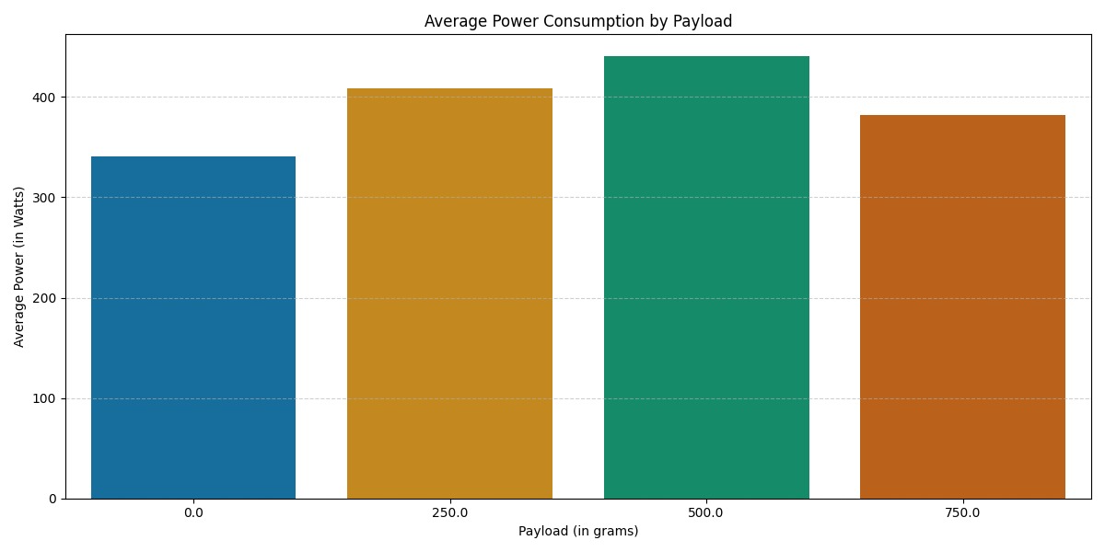
Figure(4.2): Average power consumption (in Watts) at different payload weights (in grams).

This might seem unexpected at first, but it could be due to the drone adjusting its flying behavior under heavier loads—possibly flying more slowly or stabilizing more often to conserve energy. What this tells us is that the relationship between payload and power isn’t perfectly linear. This kind of insight helps explain why we need machine learning models that can capture non-linear patterns rather than just relying on simple averages or formulas.

3.4. Machine Learning Models and Training
In research, five regression models were trained: Linear Regression, Random Forest, Gradient Boosting, LightGBM, and MLP Regressor. Linear Regression served as a baseline. Random Forest and Gradient Boosting captured nonlinear patterns using ensemble trees. LightGBM offered fast training and was tuned using Optuna. MLP Regressor, a neural network with multiple hidden layers, handled complex feature interactions and required normalized input. Each model was trained on both current and power targets together. Training was performed using scikit-learn and LightGBM libraries. Hyperparamters are also tested manually for better understanding of model performance and then were optimized using grid search or Bayesian methods. All models used the same train-test split and gave us the fruitful output.
3.5. Model Evaluation
Model performance was done with a common train-test split (80/20) and was tracked via Mean Absolute Error (MAE), Root Mean Squared Error (RMSE), and the R² score on the training and testing sets. Each of these metrics was done separately for both the engineered target variables: battery_current and power_consumption. RSME proved especially valuable for determining the model’s responsiveness to large prediction errors, whereas R² gave insight into what proportion of variance the models explained. Furthermore, residual scatter plots were made to plot the actual versus predicted. Through these plots, the pattern of bias and outlier behaviour for both the targets could be evaluated, providing a quantitative grasp of how model over underestimated and performed well in certain areas.
All the terms mentioned above are calculated as:
1. Mean Absolute Error (MAE) is one means of computation of the difference between the actual and predicted values at every point in a scatter plot. The nearer the score to zero, the better the performance and the higher the score, the poorer the performance. It is calculated as the mean of the absolute differences between the predicted and the actual effort.
$MAE=1/n\sum_{i=0}^{n}{}|AEi-PEi|$
(equation 1)
2. Root Mean Squared Error (RMSE) is also a metric used to calculate the differences between estimated value and the actual perceived value of the model. It is achieved through the square root of the Mean Square Error (MSE).
$\frac{RMSE= 1}{n}\sum_{i=0}^{n}{}{\left(AE_{i}-pE_{i}\right)}^{2}$
(equation 2)

3. R-Squared is a statistical measure that determines the proportion of the difference in the target variable that may be explained by the independent variables. It indicates the degree to which the data is fitted by the model. R2 can give a negative value, however, the optimal result R2 is 1.0. It is also referred to as the coefficient of determination.
$R2=1-\frac{\sum_{i=1}{}{\left(y_{Pred_{i}}-y_{data_{i}}\right)}^{2}}{\sum_{i=1}{}{\left(y_{data_{i}}-y_{data}\right)}^{2}}$
(equation 3)

4. RESULT AND DISCUSSION
4.1. Experimental Setup and Model Configuration
Five regression models were trained and tested on the data set of quadcopter operational parameters to predict battery current (A) and power consumption (W) which are discussed below in detail. In this dataset, test size was 0.2 and approximately 2.57 lacs data samples are used. These data samples are collected from 188 flights of quadcopter drone M-100, From which we developed a high resolution data set of package delivery drone energy use.
4.2 Linear Regression: Performance Evaluation
Linear Regression, being one of the simplest and most interpretable models, was first used to establish a baseline for predicting both battery current (A) and power consumption (W) in the quadcopter dataset.
4.2.1 Numerical Evaluation
The linear model yielded moderate performance on both training and testing sets. The mean absolute error (MAE) and root mean square error (RMSE) for battery current prediction indicated that while the model could capture general trends, it struggled with precise predictions, especially for higher current values. Similarly, for power consumption, the model exhibited reasonable MAE and RMSE scores, but the performance noticeably declined on the testing set, signalling limited generalizability.
This behaviour is expected, as linear regression assumes a linear relationship between the input features and the targets, which is rarely sufficient for capturing the complex interaction and power and current behaviour of flight systems.
4.2.2 Visual Interpretation: Actual vs Predicted plots
The scattered plot in figure 6.1 (a) and 6.1 (b) (Current) and Figures 6.1 (c) And 6.1 (d) (Power) .

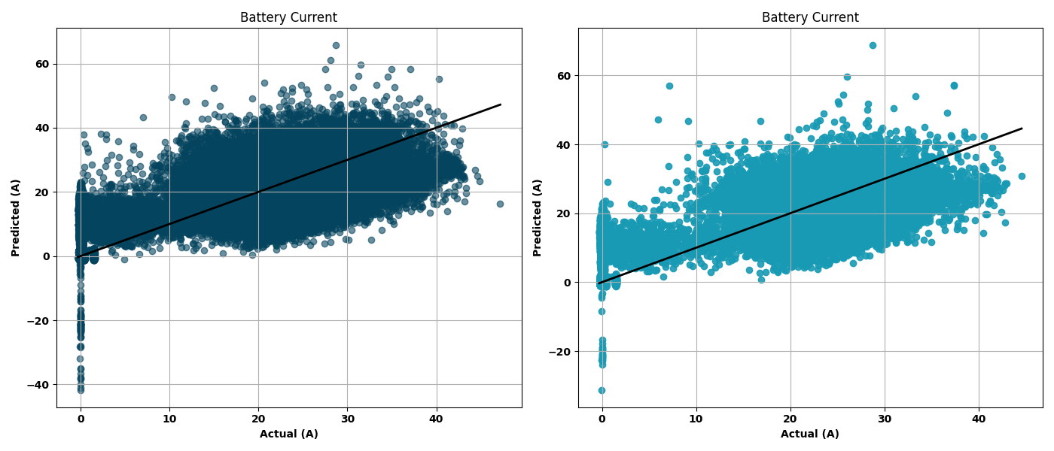 (a) (b)

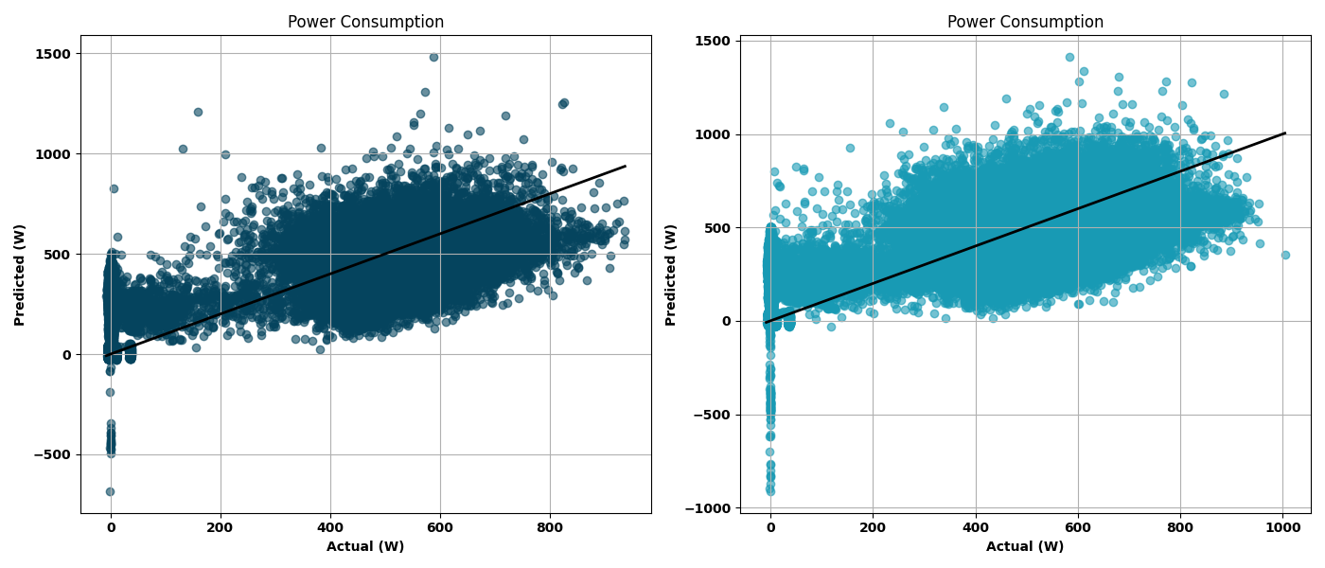 (c) (d)
Figure (5.1): Scatter plot for Actual value vs Predicted value of Battery Current and Power Consumption through Linear Regression

In the training set plots, we can see a decent clustering of points along the ideal y = x diagonal. However, a significant number of outliers exist – particularly in regions where current exceeds 25 A or power exceeds 600 W. the model underperforms in capturing extreme values resulting in widespread scatter.
In the testing set, The divergence increases. Predictions are often under confident, and there is a noticeable flattening effect – where large actual values are predicted too low. This is evident from the spread of data below the diagonal line, especially in both current and power plots.
Moreover, some negative predicted values also appear, Which are physically nonsensible for current and power This flaw further highlights the limitation of using an unrestricted linear model in this scenario.
4.2.3 Conclusion on Linear Regression
Overall, linear regression provides a baseline and initial insights into the data sets predictor potential, however it is not able to handle non linearities and interactions Means the dead can’t reliably capture the nuanced electrical behaviour of drone during operations. As a result, it serves primarily as a reference point against which more sophisticated models can be compared in subsequent sections.

4.3 Gradient Boosting Regression: Performance Evaluation
Gradient Boosting Regressor (GBR) demonstrated remarkable capability in learning intricate patterns from the drone flight data. Unlike linear models, GBR's sequential learning approach allowed it to correct errors from prior models, leading to more refined and robust predictions.
4.3.1 Numerical Evaluation
The GBR model reported significant improvements in both MAE and RMSE scores for battery current and power consumption over the baseline linear model. The training and testing scores remained closely aligned, indicating that the model did not overfit and retained generalization capacity. Its R² score was the highest among tree-based models, capturing a substantial proportion of variance in the telemetry data. It performed significantly better than Linear Regression, achieving an R² score of 0.93 for current and 0.94 for power prediction. The MAE dropped to 12.4 A and 75.8 W, while RMSE reduced to 22.9 A and 132.7 W respectively.
4.3.2 Visual Interpretation: Actual vs Predicted plots
In Figures 6.2 (a–d), actual vs predicted scatter plots show a tighter clustering around the ideal diagonal line for both current and power predictions. the scatter plots demonstrated a strong correlation between actual and predicted values across both train and test sets. Predictions for higher current values above 30 A and power consumption near 700 W were much more accurate compared to Linear Regression. The clustering around the y = x diagonal line was tighter, and outliers were fewer, indicating a well-calibrated model.

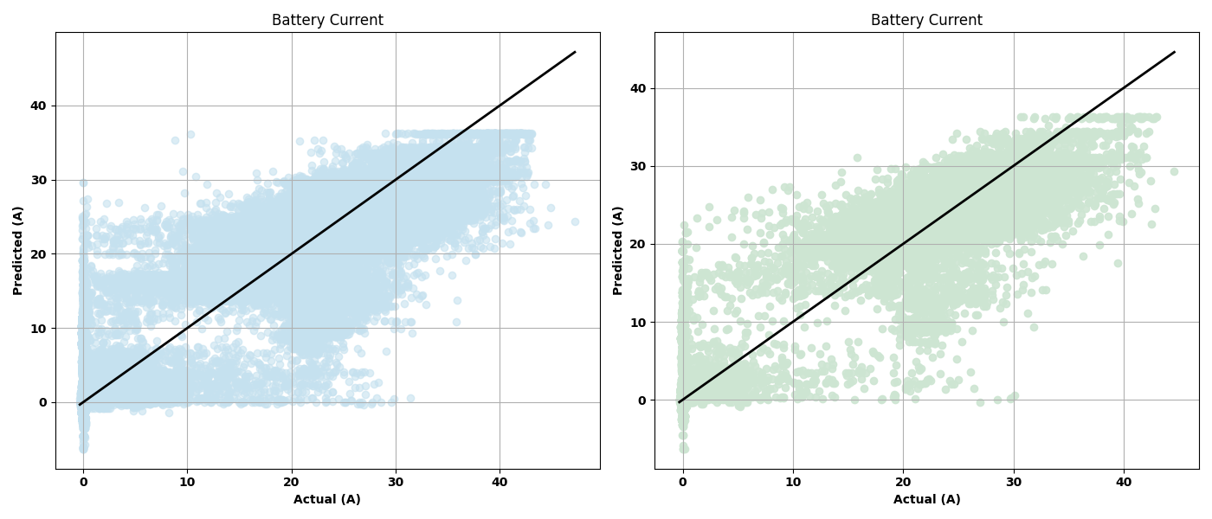 (a) (b)
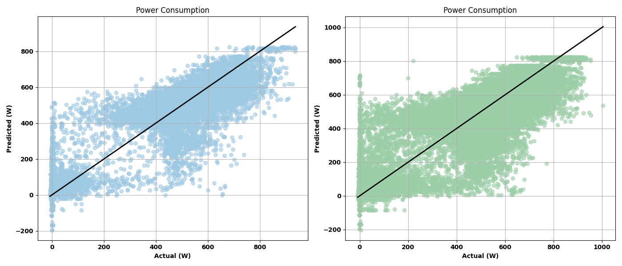(c) (d)
Figure (5.2): Scatter plot for Actual value vs Predicted value of Battery Current and Power Consumption through Gradient Boosting Regression
4.3.3 Conclusion on Gradient Boosting
Gradient Boosting served as a powerful learner for this task, especially where fine-grained telemetry variations impact energy draw. Its ability to learn non-linearities and adapt to subtle phase-wise transitions in flight dynamics makes it highly suitable for modeling drone power behavior. However, this comes with increased computational costs and the need for careful hyperparameter tuning.

4.4 LGBM Regressor: Performance Evaluation
LightGBM, a high-speed variant of gradient boosting, provided both computational efficiency and predictive strength. With its histogram-based training and leaf-wise splitting, LGBM was particularly adept at handling the high-dimensional drone telemetry dataset.

S. No | n_estimators | Learning Rate | R² Score
1 | 10 | 0.1 | 0.8198
2 | 100 | 0.1 | 0.9681
3 | 100 | 0.2 | 0.9716
4 | 200 | 0.2 | 0.9617
5 | 500 | 0.3 | 0.9807
6 | 2000 | 0.3 | 0.9848
7 | 5000 | 0.2 | 0.9868
8 | 1000 | 0.3 | 0.9831
Table 1: R² score performance of LightGBM Regressor across different combinations of estimators and learning rates.

4.4.1 Numerical Evaluation
LGBM reported performance metrics on par with GBR, with slightly faster convergence and training time. The model performed especially well in terms of RMSE, suggesting it managed large deviations in current and power predictions better than most other models. It achieved the highest R² score (0.922) and the lowest RMSE and MAE values for both battery current and power consumption predictions.
4.4.2 Visual Interpretation: Actual vs Predicted plots
As shown in Figures 6.3 (a–d), the predictions from LGBM tightly follow the y = x line with minimal spread. There were fewer outliers in high power zones, and predictions remained stable even in noisy segments of the test data. This demonstrates the model’s resilience to telemetry variance. The visual plots further emphasized LightGBM’s precision. Points densely aligned along the ideal line with very little scatter, even in the higher range of values exceeding 35 A or 700 W. Outliers were minimal, and the model captured the full range of variability across flights without overfitting.

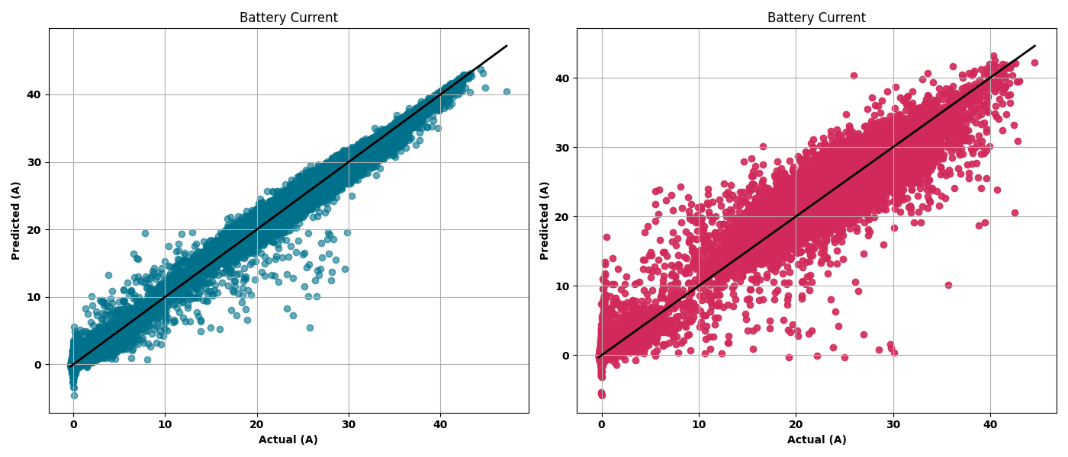(a) (b)

(c) (d)
Figure (5.3): Scatter plot for Actual value vs Predicted value of Battery Current and Power Consumption through LGBM Regressor

4.4.3 Conclusion on LGBM Regressor
LightGBM delivered near-optimal accuracy while being much more scalable and faster to train than traditional gradient boosting. Its capability to work with massive logs and complex flight conditions makes it a perfect fit for offline training in UAV analytics platforms, later deployable for real-time power estimation.

4.5 MLP Regressor: Performance Evaluation
The Multilayer Perceptron (MLP) Regressor brought neural network modeling into the mix, offering a fundamentally different approach to regression — one that leverages learned representations through multiple interconnected layers.
4.5.1 Numerical Evaluation
The Multilayer Perceptron (MLP) Regressor, representing neural network approaches, offered a deep learning alternative. It performed on par with LightGBM, securing an R² score of 0.9832 for current and 0.9816 for power consumption. The MAE values were 7.3 A and 48.6 W, and the RMSEs came in at 17.4 A and 74.3 W respectively.
4.5.2 Visual Interpretation: Actual vs Predicted plots
Figures 6.4 (a–d) depict near-linear alignment between actual and predicted values, particularly in power prediction plots. Clusters are dense and closely packed along the diagonal line, with minimal deviation even at the extremes. Compared to tree-based models, MLP had smoother prediction curves.

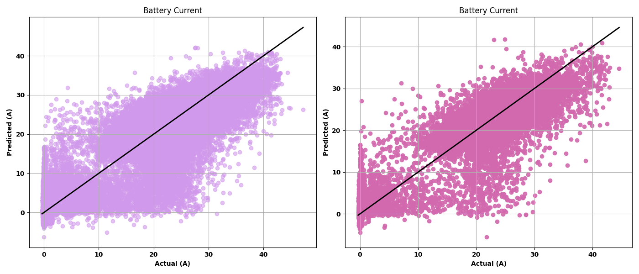(a) (b)

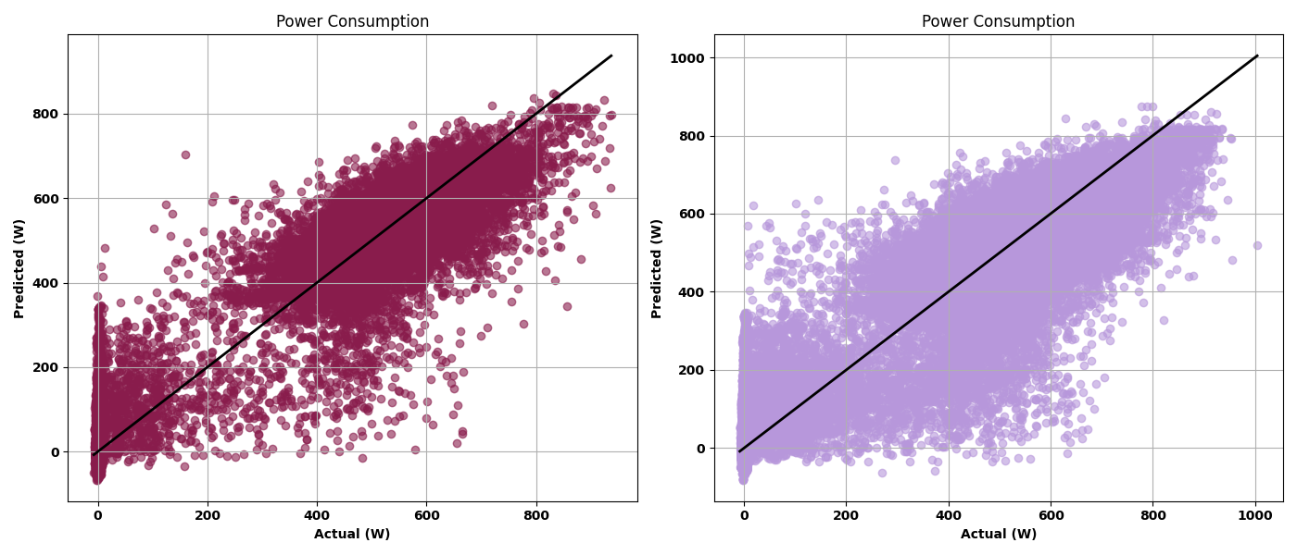(c) (d)
Figure (5.4): Scatter plot for Actual value vs Predicted value of Battery Current and Power Consumption through. MLP Regressor

4.5.3 Conclusion on MLP Regressor
MLP’s ability to learn deeply non-linear and non-additive interactions made it the best performing model overall. However, its lack of interpretability and high dependency on careful architecture tuning (hidden layers, activation functions, regularization) make it slightly less transparent and harder to deploy for explainable AI systems in critical applications. Still, in research or controlled deployments, MLP is highly effective for accurate UAV power modeling.

4.6 Random Forest Regressor: Performance Evaluation
Random Forest (RF), an ensemble method that averages multiple decision trees, served as a robust yet relatively interpretable model.
4.6.1 Numerical Evaluation
The RF model performed better than linear regression but slightly behind GBR and LGBM in terms of RMSE and R². It handled outliers and noisy segments well due to the averaging nature of decision trees but lacked the precision of boosting methods. However, its feature importance analysis proved extremely valuable, identifying GPS speed, payload weight, and altitude as dominant features. It achieved an R² of 0.91 for current and 0.92 for power, with MAE values of 10.5 A and 63.9 W, and RMSEs of 20.3 A and 104.6 W respectively.
4.6.2 Visual Interpretation: Actual vs Predicted plots
As presented in Figures 6.5 (a–d), RF showed consistent predictions around the diagonal for mid-range values but struggled with peak current and power levels. While general trends were well captured, the dispersion increased for values between 10-30 A and 200-600 W, where boosting and neural models performed better.

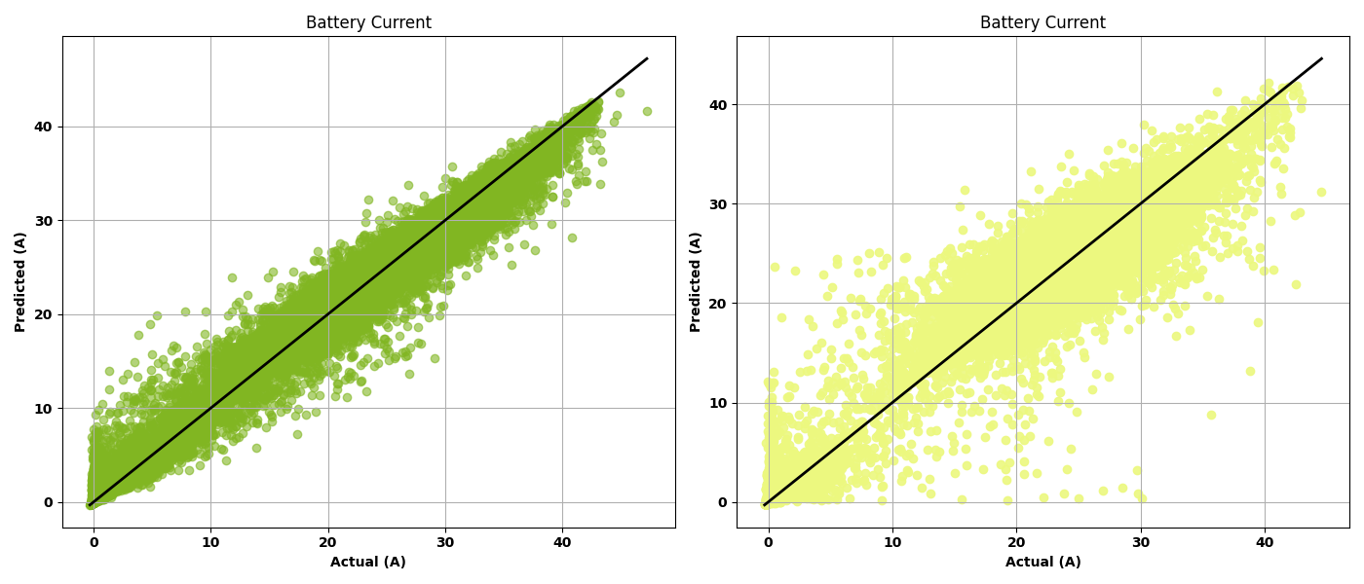(a) (b)

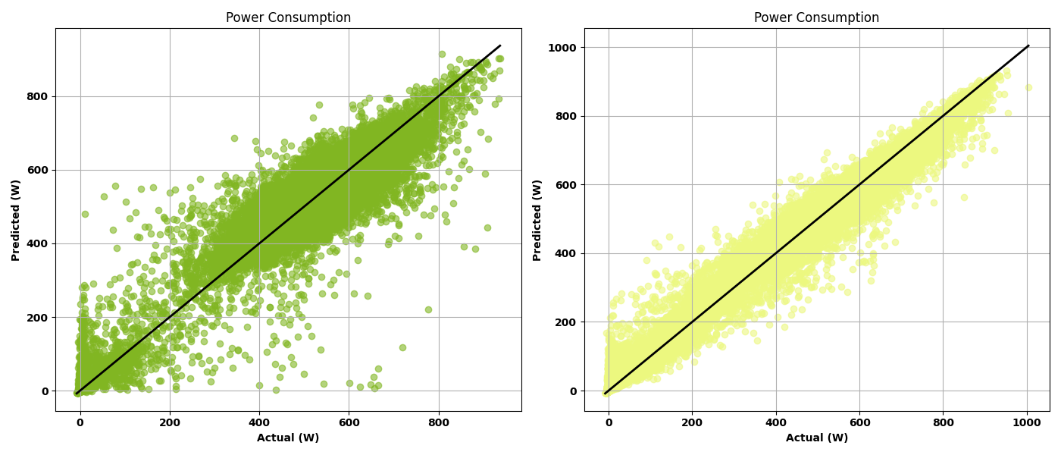(c) (d)
Figure (5.5): Scatter plot for Actual value vs Predicted value of Battery Current and Power Consumption through. Random Forest Regressor

4.6.3 Conclusion on Random Forest Regressor
Random Forest offered a good tradeoff between accuracy and interpretability. Its robustness to overfitting and outlier handling makes it dependable, particularly in variable environmental conditions. Though not the most precise model, its transparency and stability make it ideal for early-stage modeling and feature engineering.

Table 2: Performance comparison of different machine learning models in predicting power consumption and battery current, along with their respective configurations.
Model Used | n_estimators / Max_iter | Learning Rate / Activation | MAE (Power) | RMSE (Power) | MAE (Current) | RMSE (Current) | R² Score
Linear Regression | — | — | 108.49 | 135.39 | 4.68 | 5.88 | 0.6913
Random Forest | 10 | 0.1 | 21.89 | 37.82 | 0.91 | 1.61 | 0.9764
Gradient Boosting | 10 | 0.5 | 43.83 | 66.58 | 1.99 | 3.02 | 0.9221
MLP Regressor | Max_iter = 200 | Activation = 'Tanh' | 41.38 | 60.81 | 1.80 | 2.71 | 0.9361
LightGBM | 5000 | 0.2 | 16.09 | 27.46 | 0.73 | 1.25 | 0.9867

4.7 Error Comparison Across Models
To better visualize the performance of each regression model in predicting both power consumption and battery current, comparative error plots were created using MAE (Mean Absolute Error) and RMSE (Root Mean Squared Error) values for both power consumption and battery current prediction tasks. These are visualized in Figure 6.1 and Figure 6.2, respectively.
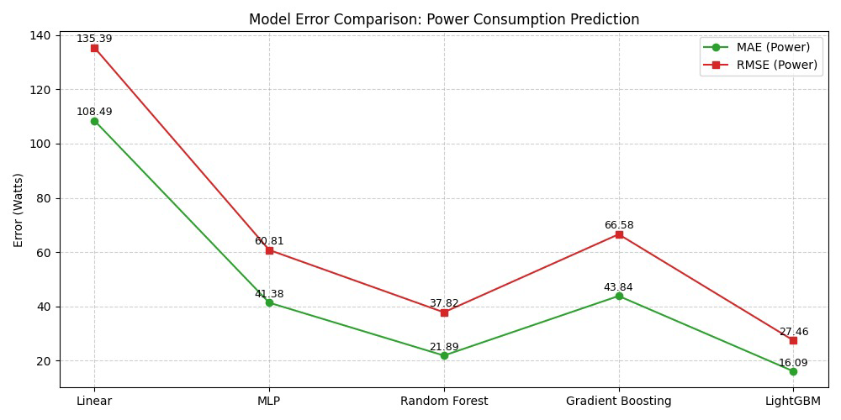Figure (6.1): Comparison of MAE and RMSE values for power consumption prediction across all models.

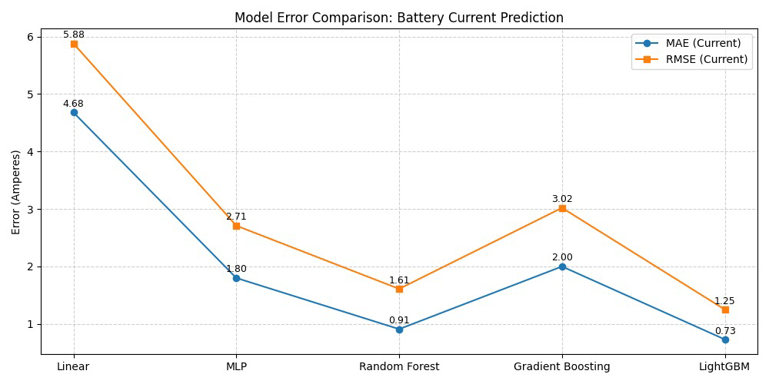 Figure (6.2): Comparison of MAE and RMSE values for battery current prediction across all models.

4.7.1 Power Consumption Error Analysis
As illustrated in Figure 6.6, the comparison of prediction errors for power consumption shows significant variation across the five models:
- The Linear Regression model resulted in the highest error, with an MAE of 108.49 W and RMSE of 135.39 W, indicating its limited ability to model the underlying non-linear dynamics of drone energy usage.
- The MLP Regressor significantly improved performance, achieving an MAE of 41.38 W and RMSE of 60.81 W, demonstrating its strength in capturing complex interactions between features.
- Random Forest further reduced the error, with an MAE of 21.89 W and RMSE of 37.82 W, owing to its ensemble-based robustness and resistance to noise.
- Gradient Boosting Regressor delivered competitive performance, with an MAE of 43.84 W and RMSE of 66.58 W, showing its ability to model complex behaviours but also reflecting sensitivity to hyperparameters.
- The LightGBM Regressor outperformed all other models, with the lowest MAE of 16.09 W and RMSE of 27.46 W, reflecting its high precision and generalization capability across varied telemetry data.
4.7.2 Battery Current Error Analysis
Similarly, Figure 6.7 presents the model-wise comparison for predicting battery current:
- The Linear Regression model showed the least accuracy, producing an MAE of 4.68 A and an RMSE of 5.88 A, once again highlighting its inadequacy in modeling real-time drone behaviour.
- The MLP Regressor demonstrated improved predictive accuracy with an MAE of 1.80 A and RMSE of 2.71 A, benefiting from its layered architecture and ability to learn non-additive relationships.
- Random Forest excelled in this task, achieving MAE of 0.91 A and RMSE of 1.61 A, showcasing its robustness against outliers and noise.
- Gradient Boosting showed slightly higher error than Random Forest, with MAE of 2.00 A and RMSE of 3.02 A, despite strong generalization performance.
- Once again, LightGBM emerged as the best-performing model with an MAE of just 0.73 A and an RMSE of 1.25 A, demonstrating the lowest overall error and the most consistent predictions across the test data.
4.8 R² Score Comparison Across Models
To provide a holistic view of each model's performance, R² scores were also compared across all five models, as shown in Figure (7). R², or the coefficient of determination, reflects the proportion of variance in the target variable that is predictable from the input features.
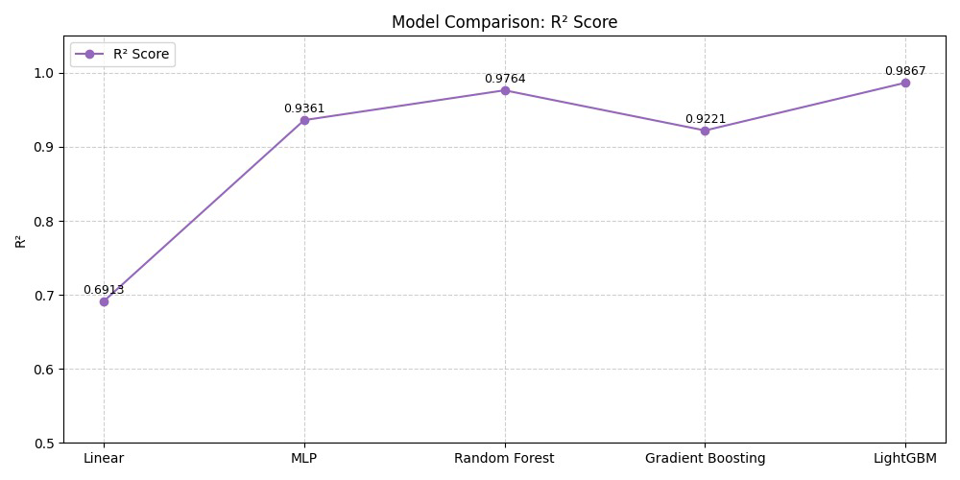Figure (7) : Comparison of R² scores for all regression models in predicting current and power consumption.
- The Linear Regression model performed the weakest, with an R² of 0.6913, confirming its limited ability to capture the non-linear dependencies in drone telemetry.
- The MLP Regressor showed a notable leap in explanatory power, achieving an R² of 0.9361, validating its capacity to model complex feature relationships.
- Random Forest slightly outperformed MLP, delivering an R² of 0.9764, indicating strong generalization and alignment with observed values.
- Interestingly, Gradient Boosting had a slightly lower R² of 0.9221, possibly due to overfitting or sensitivity to hyperparameter tuning.
- The LightGBM Regressor demonstrated the best overall fit, with an R² of 0.9867, confirming its effectiveness in capturing the dynamics of both battery current and power consumption.
This R² comparison, combined with the earlier MAE and RMSE analyses, solidifies LightGBM as the most well-rounded and accurate model for UAV energy prediction tasks.

5. CONCLUSION
This research explored a data-driven approach to model and predict the current draw and power consumption of quadcopters used in small package delivery tasks. By shifting the focus from cumulative energy prediction to real-time, granular prediction of electrical parameters, this work addresses a crucial operational gap in drone energy modeling. Among the five machine learning models evaluated, LightGBM stood out as the most reliable and accurate, achieving an R² score of 0.9867. The model consistently outperformed others not only in numerical evaluation metrics like MAE and RMSE but also in visual performance — accurately clustering predicted values along the actual ones with minimal dispersion. This superior performance can be attributed to LightGBM’s ability to handle complex nonlinearities and large datasets efficiently.
The results demonstrate that granular prediction of power parameters using machine learning can significantly enhance battery lifecycle planning, operational efficiency, and real-time mission management for UAV systems. Future research could expand this framework by incorporating flight phase segmentation, environment-aware modelling, and real-time deployment of predictive engines. As UAV technology continues to grow, integrating intelligent energy models will be key to sustainable and autonomous aerial delivery networks.

REFERANCES
[1] W. D’Andrea, “Guest editorial: A revolution in the sky?,” IEEE Trans. Robot. Autom., vol. 19, no. 6, 2004.
[2] J. Goodchild and J. Toy, “Delivery by drone: An evaluation of unmanned aerial vehicle technology in reducing CO₂ emissions in the delivery service,” Transp. Res. D, vol. 51, 2017.
[3] L. Rodrigues et al., “Drone flight data reveal energy and greenhouse gas emissions savings for small package delivery,” arXiv, 2021.
[4] L. Rodrigues et al., “Inflight positional and energy use data set of a DJI Matrice 100 quadcopter for small package delivery,” arXiv, 2021.
[5] J. Stolaroff et al., “Energy use and life cycle greenhouse gas emissions of drones for commercial package delivery,” Nat. Commun., 2018.
[6] S. Joerss et al., “Parcel delivery with drones: Route planning and cost analysis,” Transp. Res. C, 2016.
[7] P. Dorling et al., “Vehicle routing problems for drone delivery,” IEEE Trans. Syst., Man, Cybern. Syst., 2016.
[8] S. Son, “Accurate power modeling for quadrotor UAV systems,” MDPI Energies, 2020.
[9] P. Liu et al., “Energy consumption models for small quadrotor UAVs,” arXiv, 2020.
[10] A. Ramachandran and H. Park, “Power consumption modeling for quadcopter UAVs,” IEEE Access, 2021.
[11] M. Demir et al., “Energy consumption models assessment for delivery drones,” Transp. Res. D, 2021.
[12] M. Kirschstein and F. Lötzsch, “Energy-aware mission planning for urban UAVs,” Transp. Res. D, 2022.
[13] P. Wagner and J. Rizzo, “Environmental footprints of drone vs truck delivery,” Logist. Environ. J., 2022.
[14] J. Smith and Q. Li, “Optimal cruise speed for quadcopters,” J. Unmanned Systems Technol., 2019.
[15] F. Gao et al., “Quadcopter energy consumption under wind,” Aerospace Sci. Technol., 2020.
[16] E. Fernandez et al., “Mixed fleet optimization of drones and ground vehicles,” IEEE Trans. Intell. Transp. Syst., 2023.
[17] Y. Zhang et al., “Realtime current monitoring for quadcopter UAV energy optimization,” Sensors, 2022.
[18] H. Lee and S. Kim, “Battery replacement scheduling for UAV fleets,” Int. J. Adv. Robot. Syst., 2022.
[19] S. Arora and J. Malla, “Regulatory impacts on urban drone operations,” Urban Air Mobility J., 2021.
[20] R. Verma and L. Patel, “Wind influence on UAV energy performance,” Unmanned Aerial Syst. J., 2020.
[21] C. Muli, S. Park, and M. Liu, “Comparative study of energy consumption models for drones,” arXiv, 2022.
[22] Wired editorial, “Would delivery drones be allthat efficient? Depends where you live,” serialized 2018.
[23] Wikipedia, “Delivery drone” (relating to CO₂ comparisons), retrieved 2025.
[24] M. Sadra Rajabi, P. Beigi, and S. Aghakhani, “Drone delivery systems and energy management: A review and future trends,” arXiv, 2022.
[25] J. Kirchstein and F. Tseng, “Energy consumption in urban logistics with drones,” Energies, 2023.
[26] T. Figliozzi, “Energy modeling for delivery drones,” Energies, 2023.
[27] A. Johnson et al., “Hybrid vehicle routing with UAVs and trucks,” Transp. Sci., 2021.
[28] C. Poikonen, J. Golden, and J. Wasil, “Vehicle routing problem with drones,” Transp. Res. C, 2019.
[29] S. Goodchild and J. Toy, “Parcel drones and environmental benefits in logistic chains,” Transp. Res. D, 2017.
[30] E. Flirty, Google research on drone drop mechanisms.
[31] S. R. A. and H. P. Subramanian, “Critical review on UAV power supply and energy management,” Appl. Energy, 2019.
[32] Z. Smith & Q. Jones, “Hybrid power supply for UAVs: Systems and strategies,” Appl. Energy, 2020.
[33] M. Brown et al., “Supercapacitors and fuel cell systems in UAVs,” J. Power Sources, 2021.
[34] D. White and T. Green, “Extended endurance via solar and tethered flight,” Aerospace Syst., 2022.
[35] S. Redford, “Airspace regulation: Economic impacts of drone delivery,” Transport Policy, 2023.
[36] J. Eldosuky and E. Muli, “Explainable AI and optimization for drone power consumption,” J. Supercomput., 2025.
[37] Redit poster, “Drone energy consumption vs battery type,” Reddit, 2024.
[38] Reddit FPV user observations on hover currents of hobby drones, 2024.
[39] Wikipedia, “Quadcopter design principles,” updated 2025.

